HONG KONG INSTITUTE OF VOCATIONAL EDUCATION

**Laboratory 1: ProjectLibre**

**Module Intended Learning Outcome:**

On completion of the module, students are expected to be able to:

* Exercise appropriate judgment in planning and controlling software development project using ProjectLibre.

**TASK:**

ProjectLibre is an open-source alternative to Microsoft Project. It is available to download on the official website: <https://www.projectlibre.com/>

Available on Windows, Mac & Linux. It also supports Microsoft Project file format (.mpp).

**Overview of the User Interface**

The default view in ProjectLibre is the **Gantt Chart View**. It has two main areas, the **task table** and the **timescale**. The task table lists the project tasks and their accompanying information. The timescale displays taskbars corresponded to the tasks listed in the task tables. The taskbars show the duration of each task, from their planned start date to their planned finish date, over time. You can move the separator bar between the timescale and the task table to the left or right to display more either area.

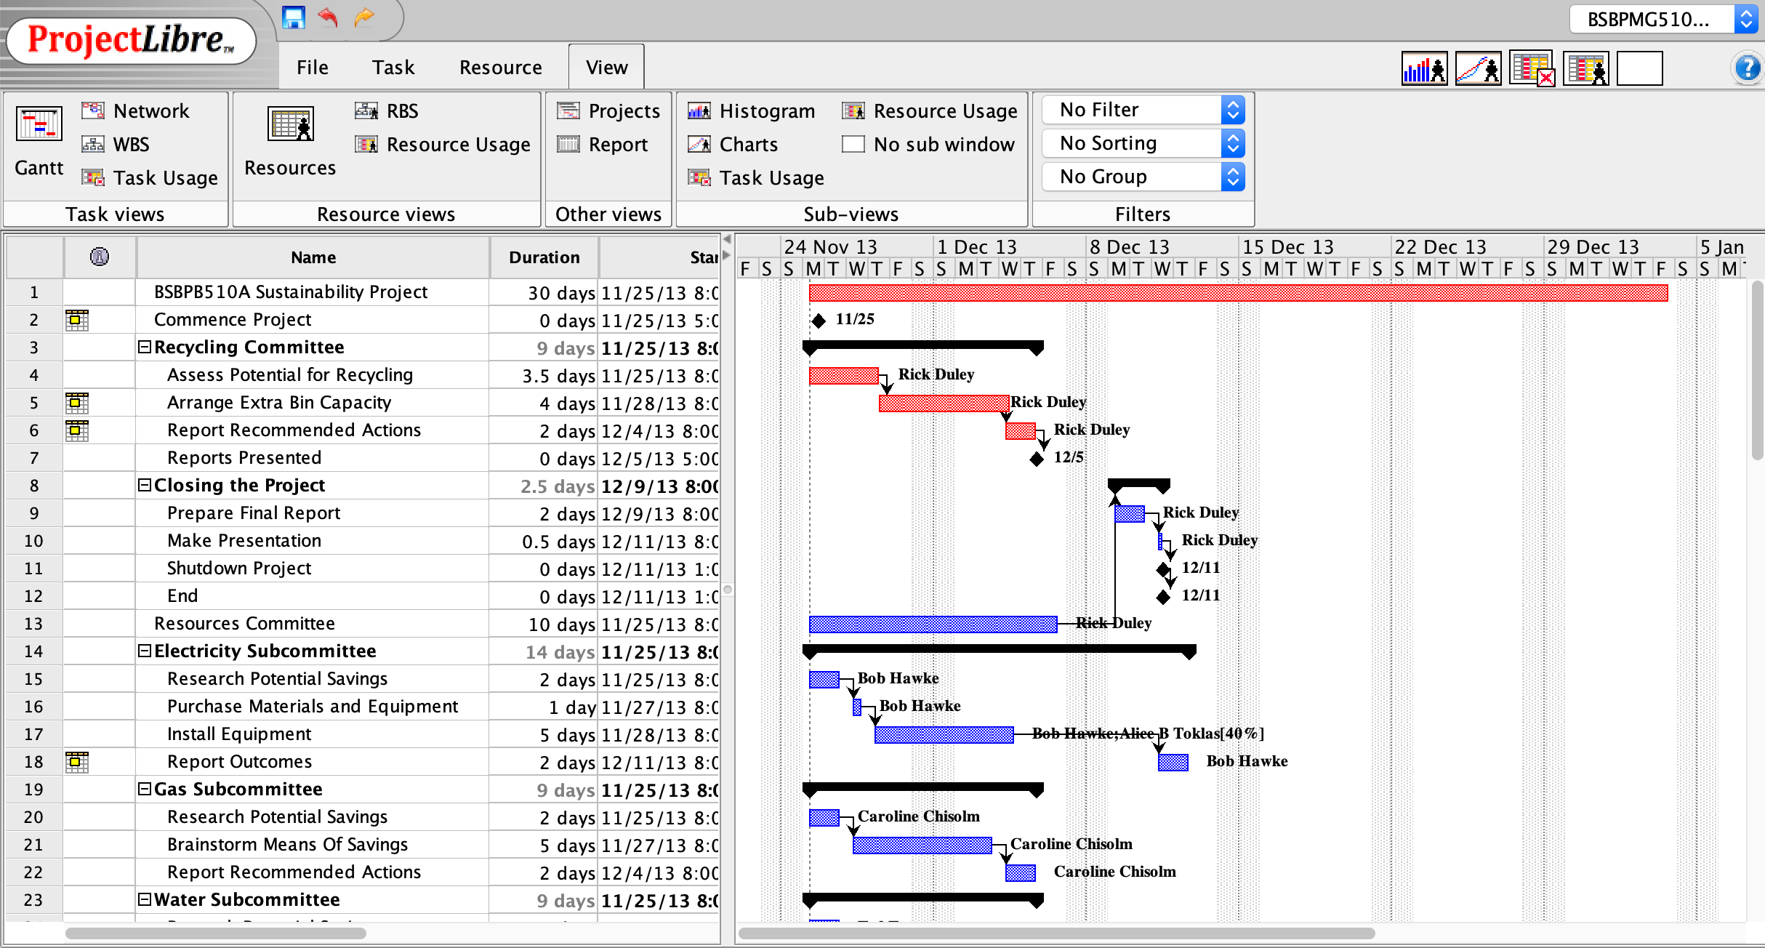

Timescale

Task Table

1. Open ProjectLibre, click **Create Project**.

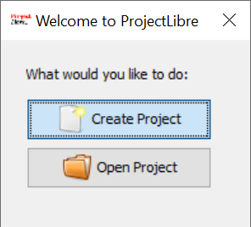

2. Enter the Project Name and Start Date, leave the option of **Forward scheduled** checked.

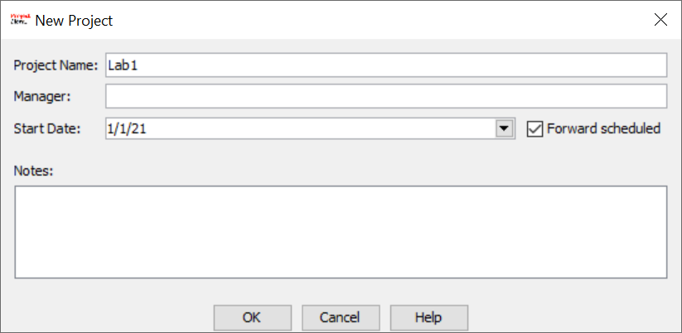

**Creating Manually Scheduled Tasks:**

1. In the first row of the Task Table, enter “**Collect Requirements**” in the **Name** field.

2. Enter **1w** in the **Duration** field. This sets the duration of the task to **5 days** by default (5 working days a week).

3. Enter the **First day of the current year** in the start field. ProjectLibre automatically calculates the finish date using the given information and fills the **Finish** field. Also, a taskbar appears in the timescale showing the task’s time frame.

4. In the second row of the Task Table, enter “**Analyse Requirements**” in the **Name** field. Enter **2d** in the **Duration** field.

5. In the third row of the Task Table, enter “**Compose Analysis Report**” in the **Name** field. Enter **2w** in the **Duration** field.

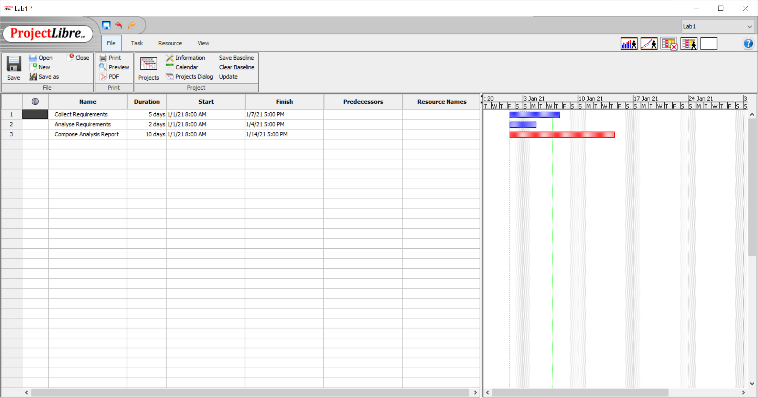

**Linking Tasks**

1. Select all three tasks by Clicking the **Name** column, or by holding the **Ctrl** key and click the 3 tasks.

2. Click the **Task** menu on the top and click **Link**.

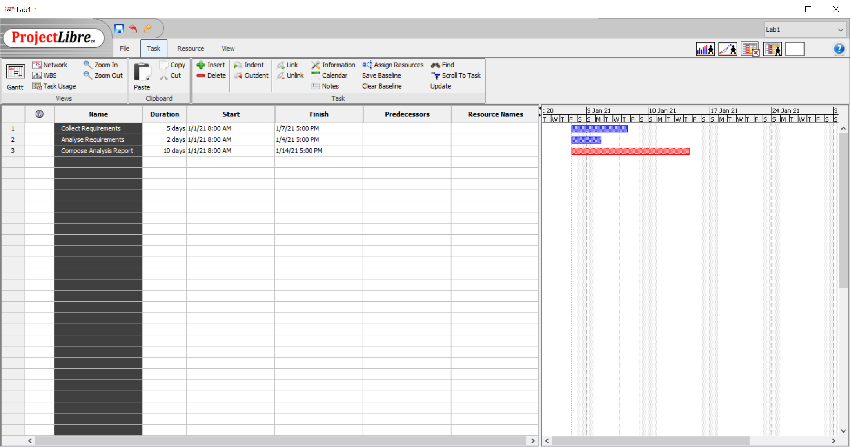

3. Task dependencies will be added after clicking **Link.** The **Start**, **Finish** and the **Predecessors** fields will all be updated automatically. Also please note the changes in Gannt Chart, arrows indicate the task dependencies.

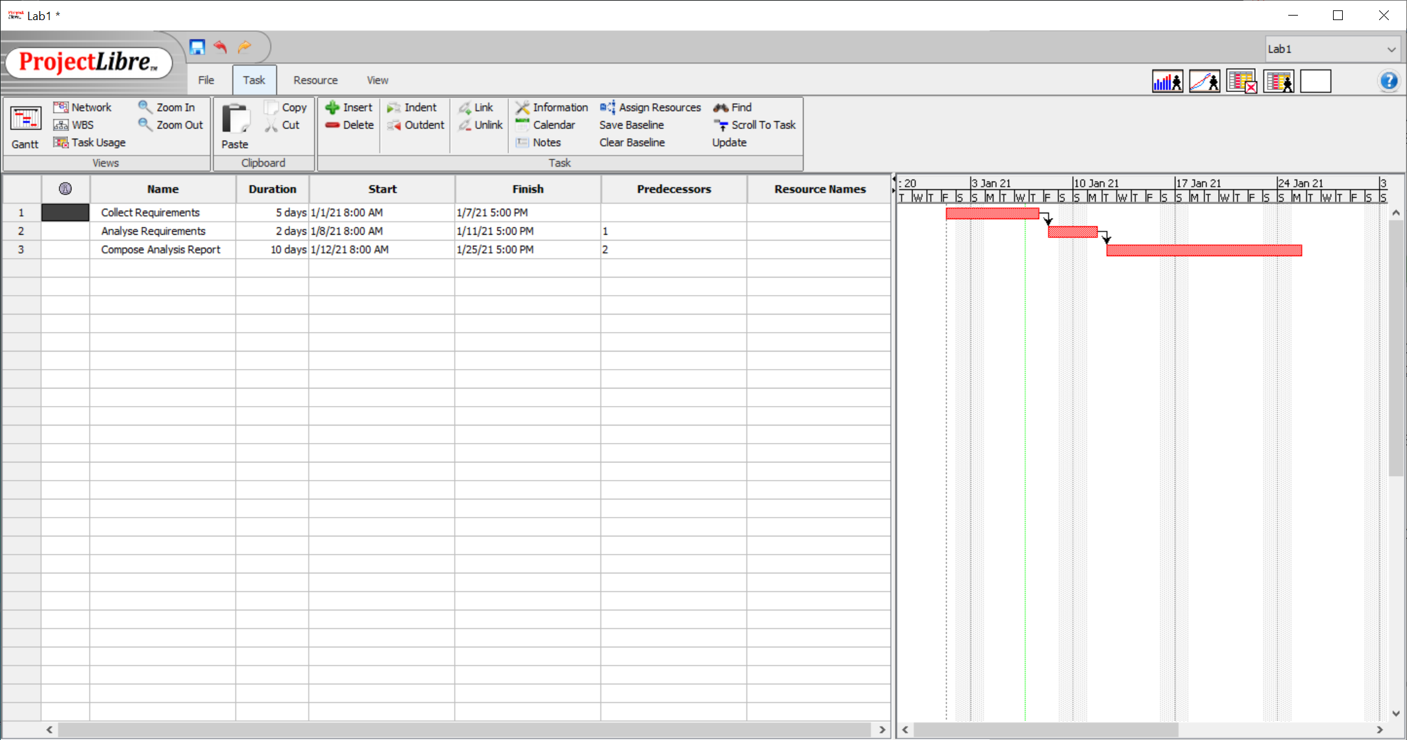

4. To see the advantage of linking tasks, change the duration of “**Collect Requirements**” to **2w**. Note the changes on the **Start** and **Finish** fields of the tasks.

5. Change the duration of the “Collect Requirement” back to **1w**.

**Creating a Summary Task**

1. Click the number 1 to select the first row, then click **Insert** to add a new row above.

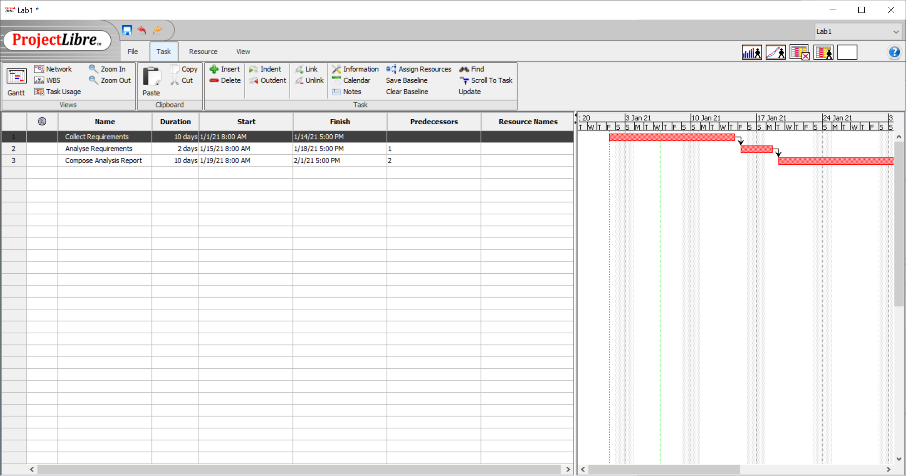

2. Enter “**Requirement Analysis**” in the Name field.

3. Select Row 2-4 by holding the **Ctrl** key and click the 3 tasks.

4. Click **Indent**.

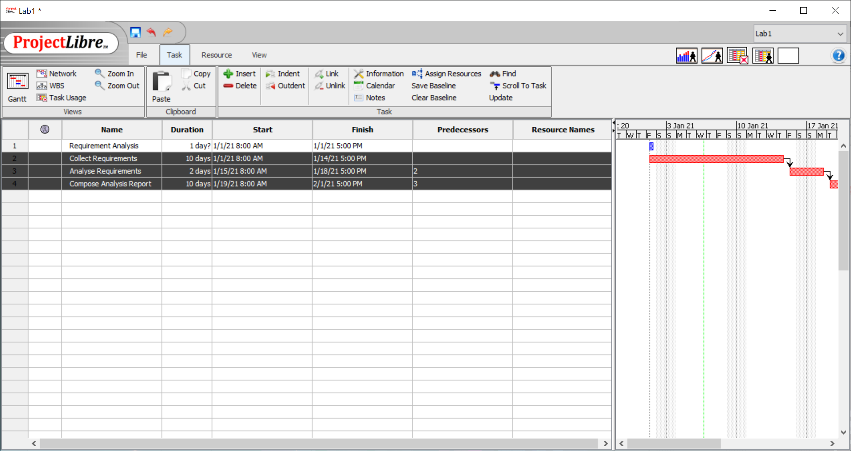

5. **Requirement Analysis** now becomes a summary task with 3 subtasks under it, namely, **Collect Requirements**, **Analyse Requirements** and **Comprise Analysis Report** respectively.

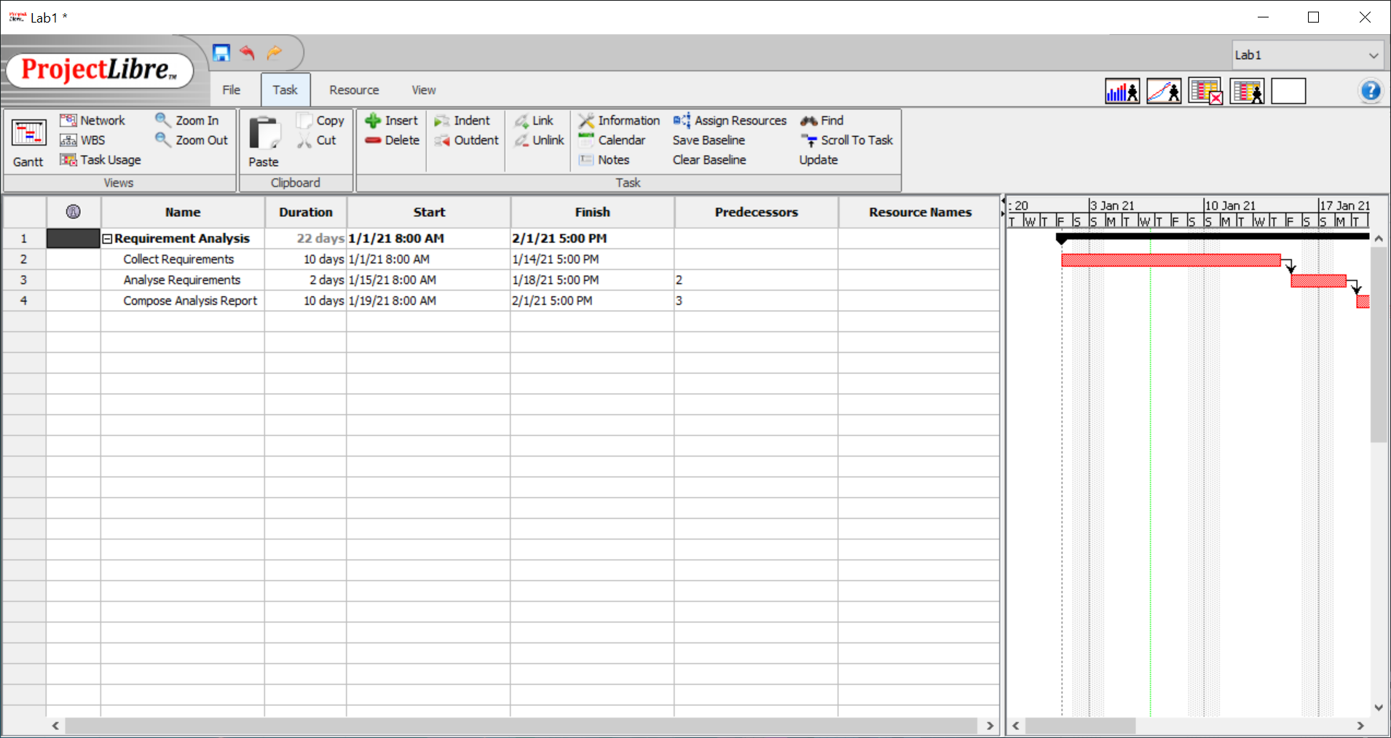

**Updating Task Progress**

1. To update a task’s percentage of completion, double-click “**Collect Requirements**” in the **Name** column to open the **Task Information** window.

2. On the **General** tab, change the **Percent Complete** field to **50%**.

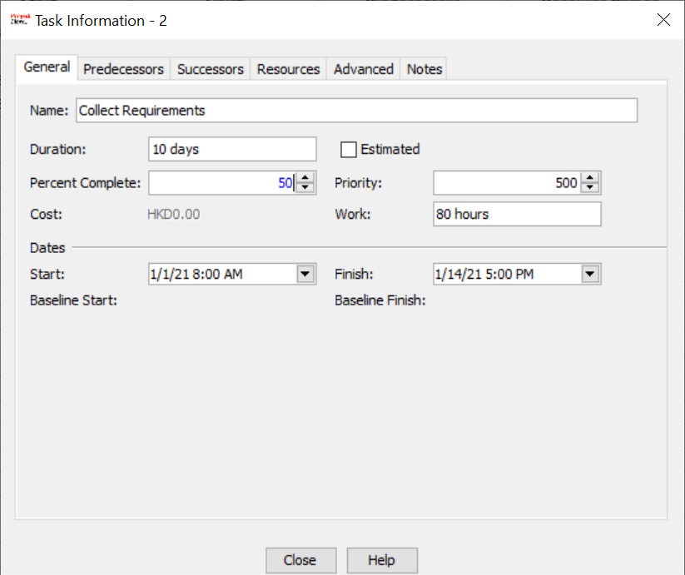

3. A progress bar will be shown within the “**Collect Requirement**” to indicate the progress of the task.

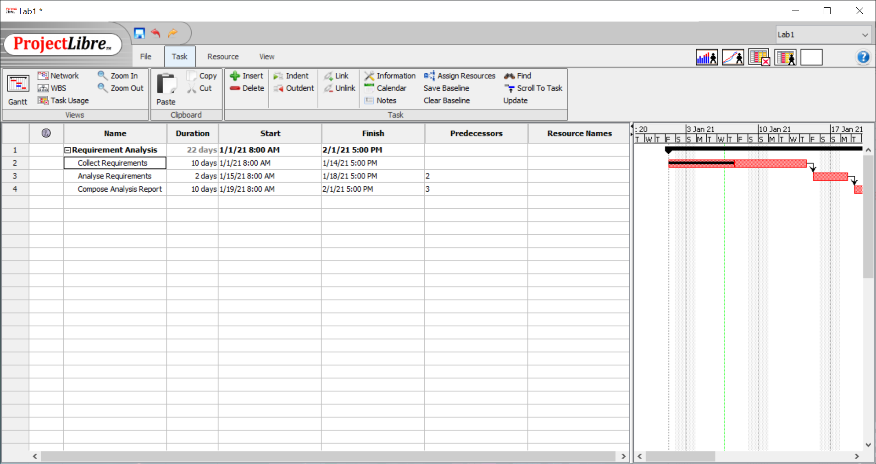

**Adding Work Resources**

1. Click the **Resource** menu on the top and click **Resources**.

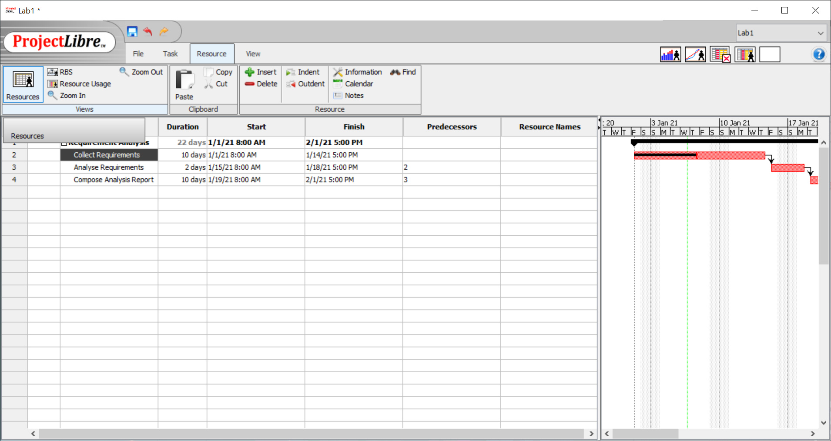

2. Enter “Student A” in the **Name** field, the **Type** field is set to “Work”.

3. Enter “SA” in the **Initials** field.

4. Enter “YR1 student” in the **Group** field

5. Enter “35” in the **Standard Rate** field. This sets the hourly rate to HKD35.00/hour.

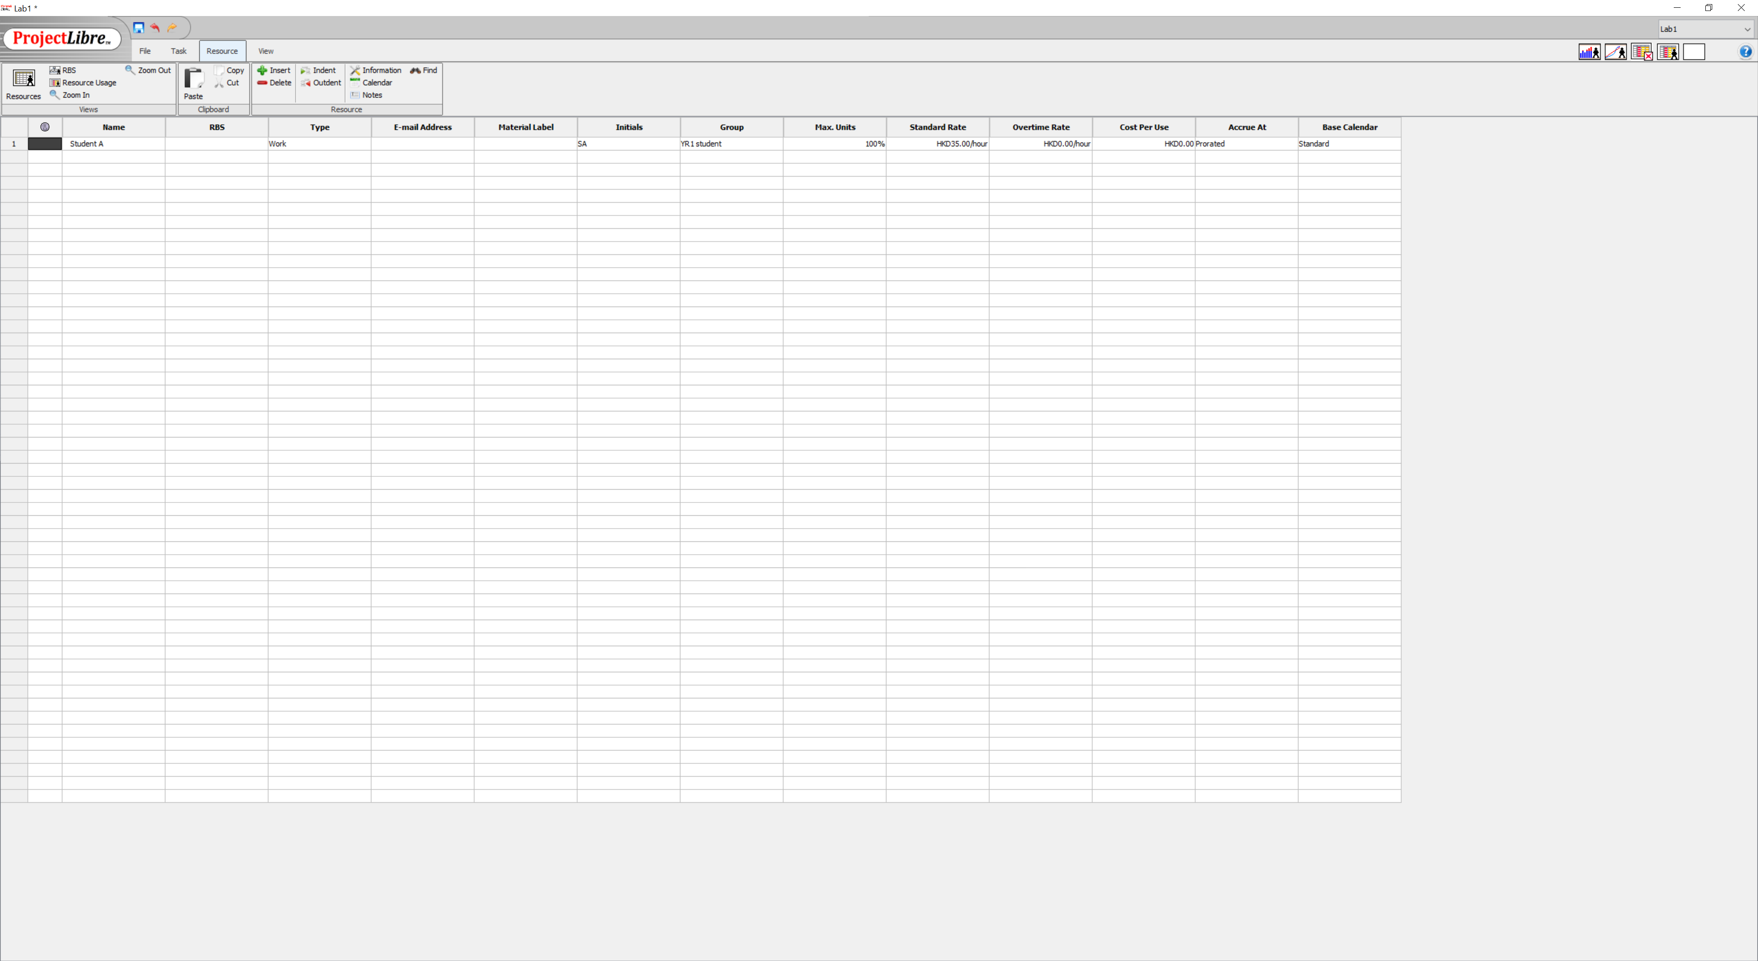

**Changing Resource Work Hours**

1. To update a resource’s working hour, double-click “Student A” in the **Name** column to open the **Resource Information** window.

2. On the **General** tab, click the **Changing Working Time** button to open the **Change Working Calendar** dialogue box.

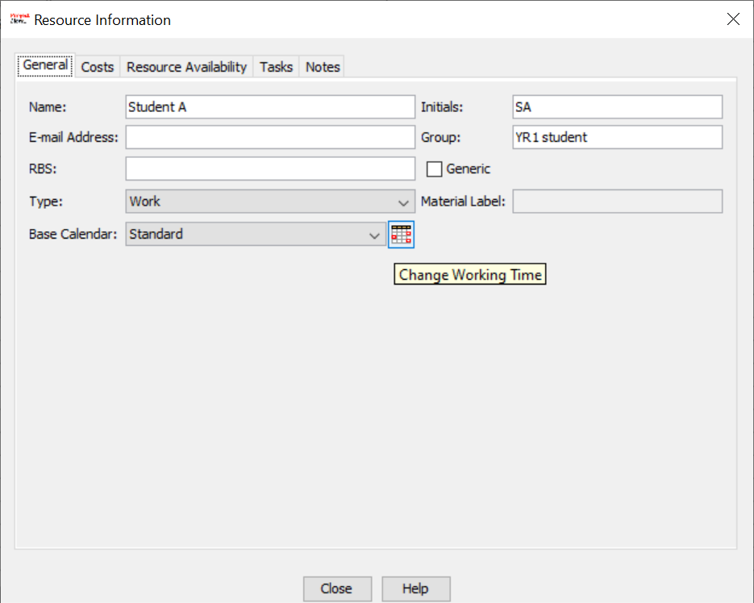

3. Select **Monday** through **Friday** by holding the **Ctrl** key and click through the letter **M** to **F**.

4. Click **Non-default working time** to assign customized working time for Student A.

5. Change the **From** time on the first row to **9:00** and **To** time on the second row to **18:00**.

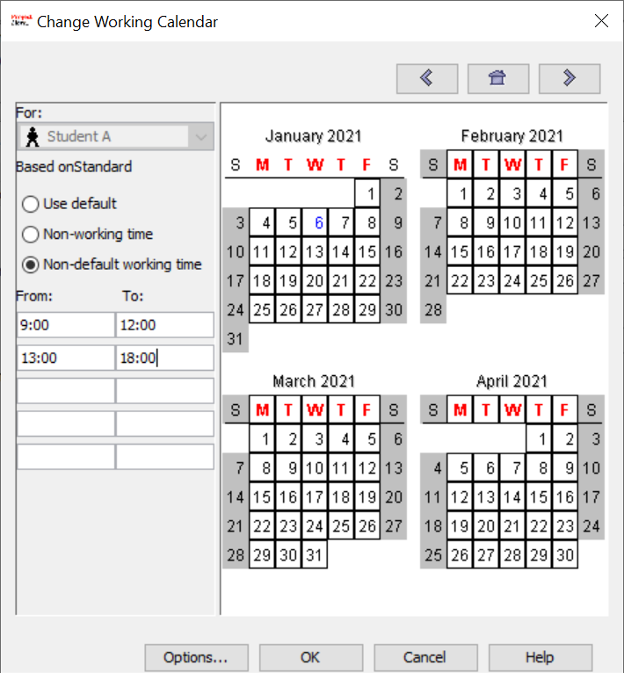

6. Click **OK** and **Close**.

**Assigning Resource to a Task**

1. Click the **Task** menu on the top and click **Gantt** to switch back to **Gantt Chart View**.

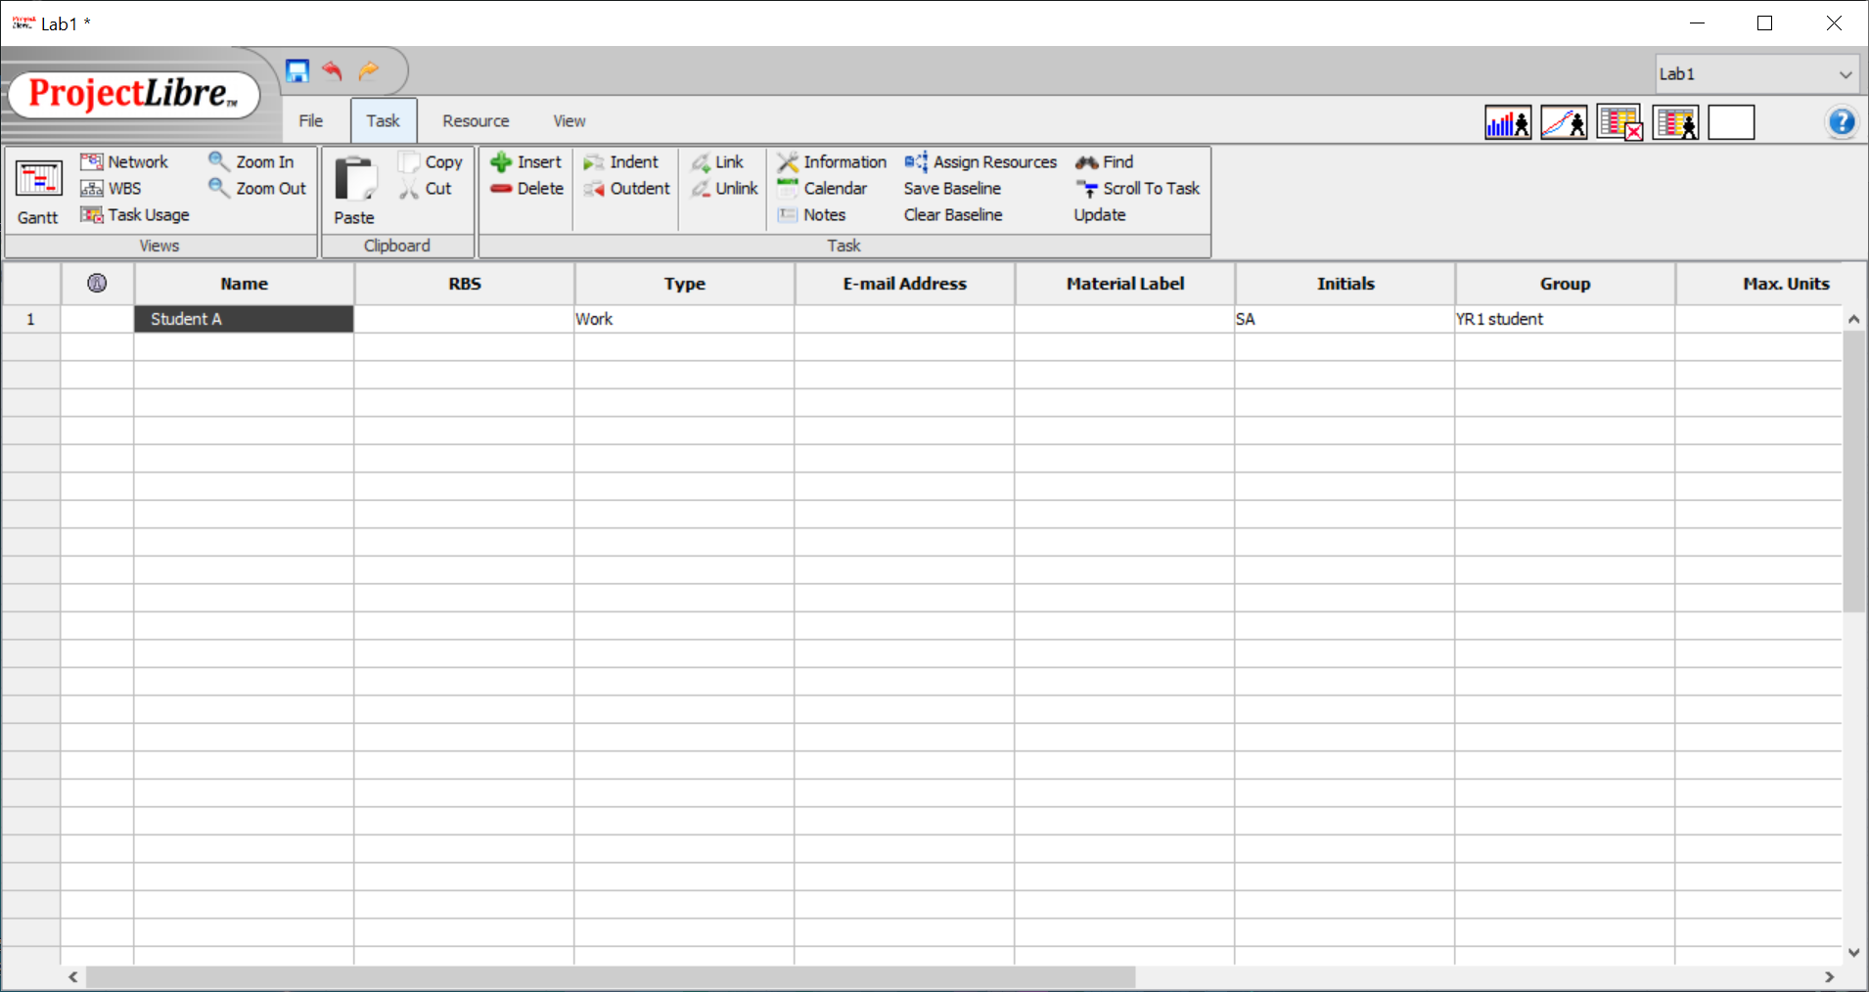

2. In the task table, select “**Collect Requirements**”, and click **Assign Resources**.

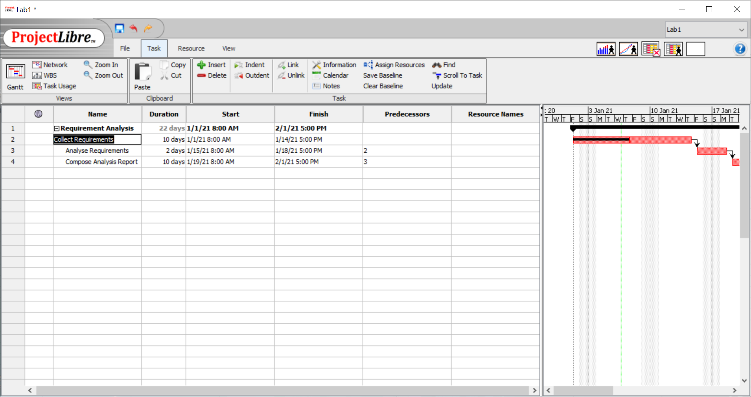

3. Assign **100%** **Units** and Click the **Tick** button to assign Student A to this task.

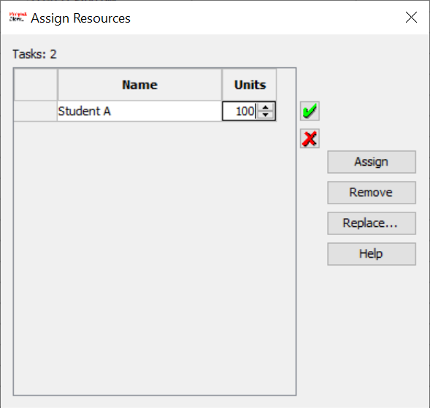

4. **Resource Names** field and the **Gannt Chart** will be updated to indicate the resources assigned to a particular task.

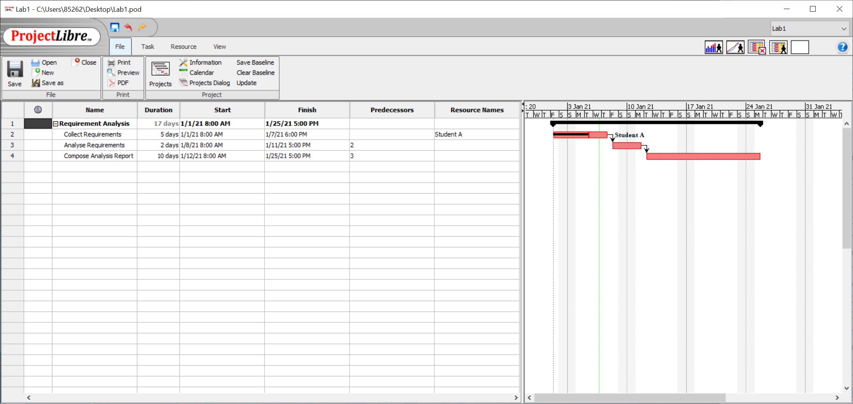

**Changing Project Work Hours**

1. Project Work Hours can also be changed by clicking the **Calendar** button.

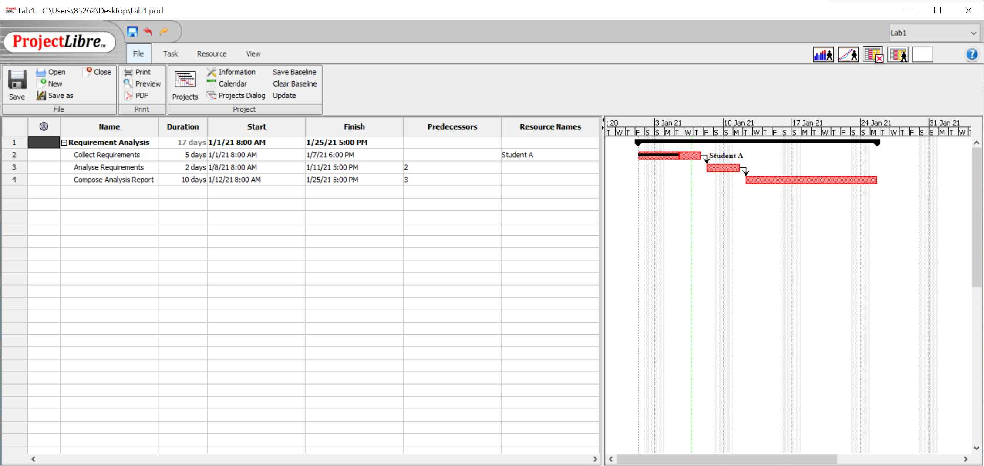

2) Click 1st Jan, mark it as **Non-working time** because it is a public holiday, then click OK.

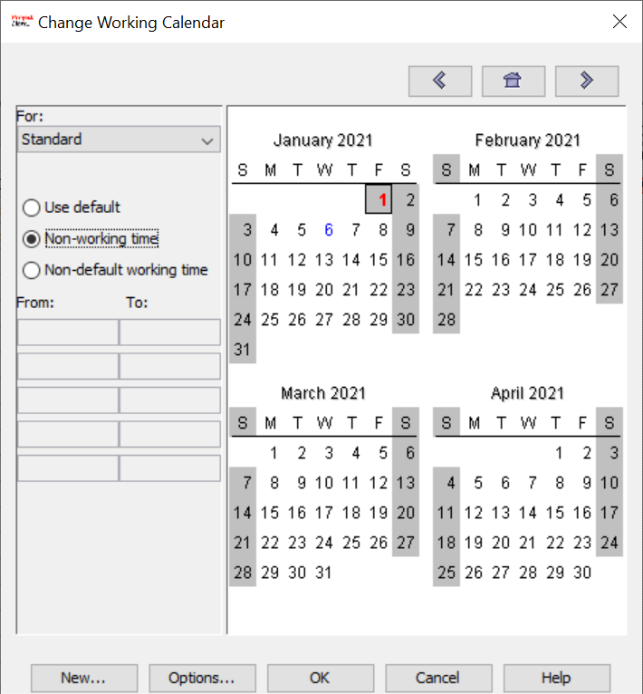

3) You can save the project once (save as Lab1.pod), close ProjectLibre.

4) Reopen it again and see the update in **Start** and **Finish** fields.

*Note: You may not be able to see the changes if you choose not to reopen the software.*

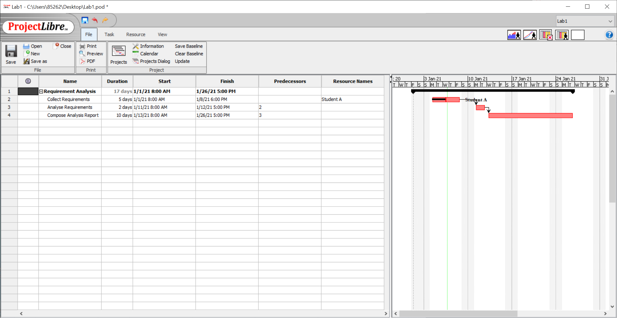

**Setting Schedule Constraint**

1. To apply schedule constraint on a particular task, double-click “**Compose Analysis Report**” in the **Name** column to open the **Task Information** window.

2. On the **Advanced** tab, set the **Constraint Type** to “**Start No Earlier Than**” and set the **Constraint Date** to **1 day** after its original start date.

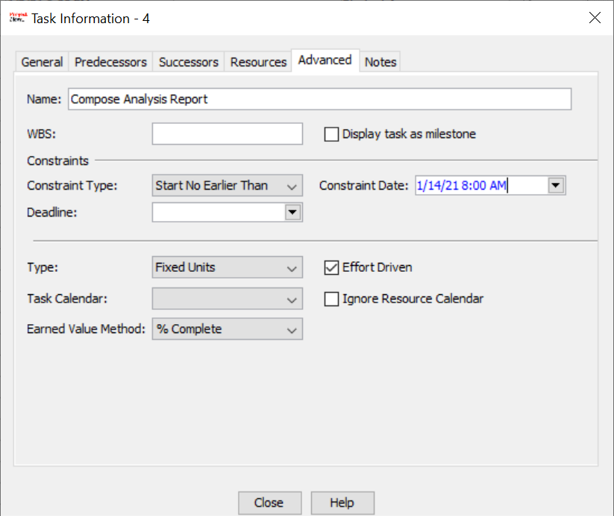

3. Note the changes on the **dates** and **Gannt Chart**.

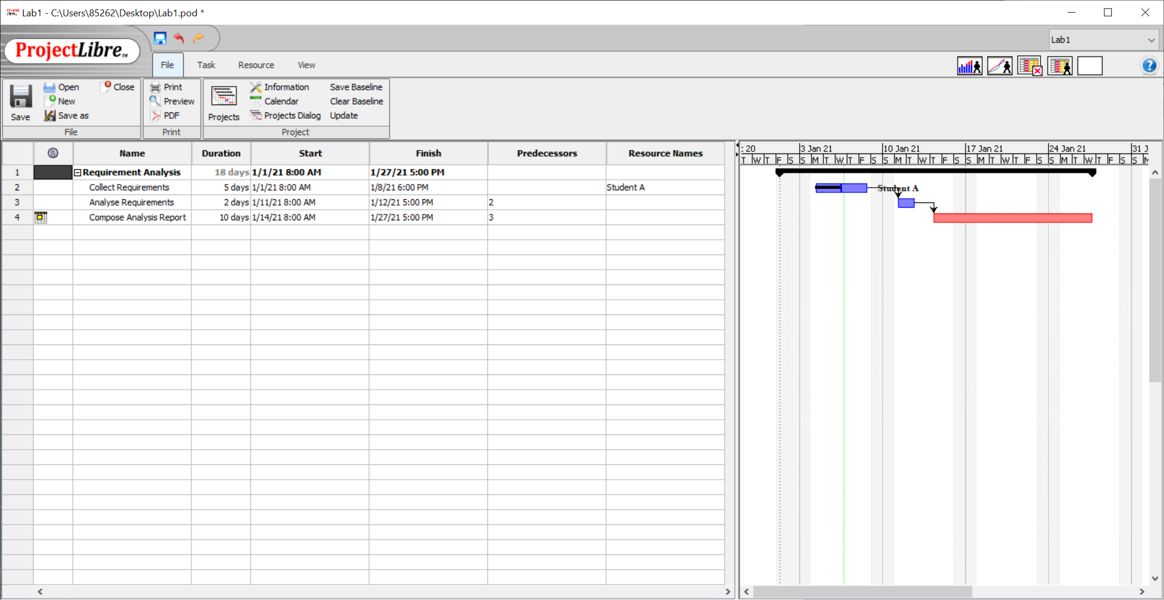

**Exercise:**

1. Add another resource: Name = “Student B”, Type = “Work”, Initials = “SB” Group = “YR2 Student”, Standard Rate = 50. Try assigning Student B to different tasks and note its effect on the project duration.

2. Why is the task bar for **Compose Analysis Report** in red? What does that mean?

3. Referring to the lab case, draw the **Gantt Chart** and estimate the finishing date for the project.